TAJANSTVENA PROŠLOST ZEMLJE

**Zadatak riješi pomoću geografske karte**.

Na karti Europe zaokruži **plavom** bojom i imenuj primjer jedne planine nastale alpskom orogenezom, **crvenom** gorje nastalo hercinskom, a **smeđom** kaledonskom orogenezom.

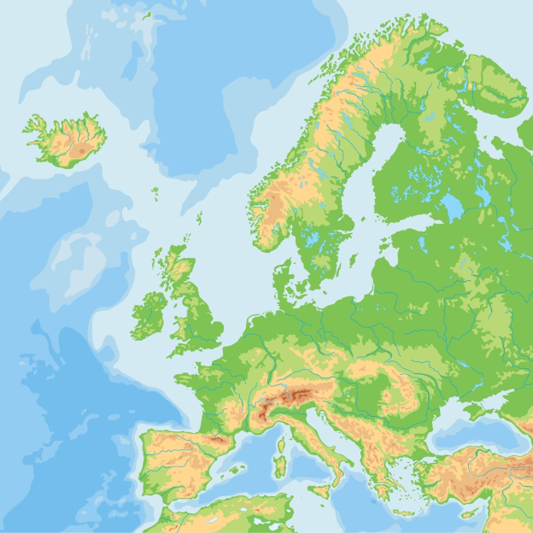

Alpska orogeneza: __________________________________________

Hercinska orogeneza: _______________________________________

Kaledonska orogeneza: ______________________________________