PADALINE – NASTANAK I GEOGRAFSKA RASPODJELA

**1. Imenuj vrstu oblaka na prikazu označenih slovima.**

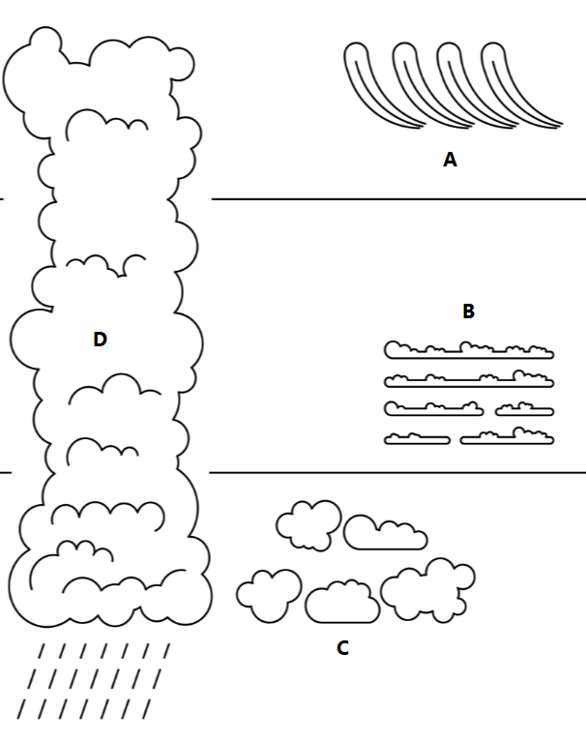

A. A ____________________________________

B ____________________________________

C ___________________________________

D____________________________________

**2. Odredi vrstu padalina (i upiši naziv na crtu) čiji je postanak prikazan na shematskom prikazu.**

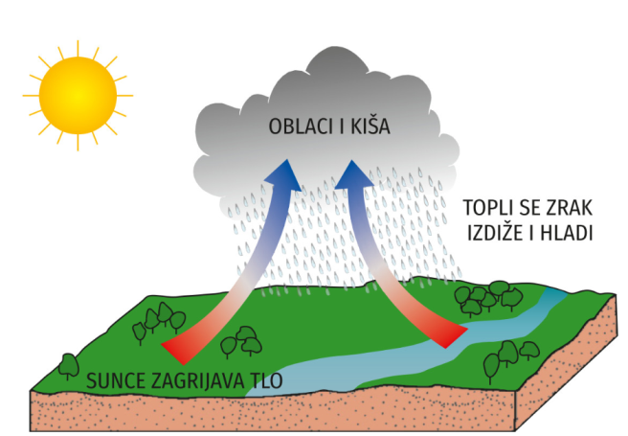 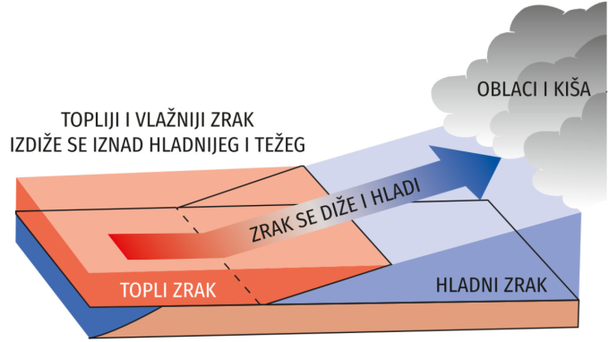

______________________________________ ______________________________________

**3. Objasni kako gradski prostor utječe na zonalni raspored padalina.**

______________________________________________________________________________________________________________________________________________________________________

______________________________________________________________________________________________________________________________________________________________________

**4. Sljedeći zadatak riješi pomoću geografske karte.**

Na geografskoj karti svijeta iscrtkaj (**///**) prostore za koje su karakteristične zenitne kiše.

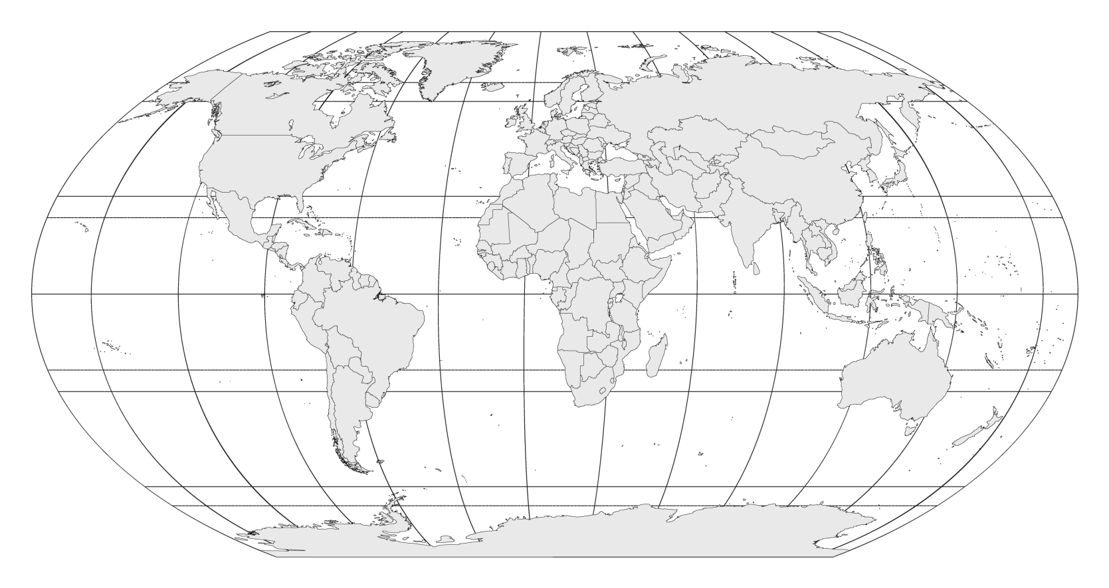

**5. Opiši svojim riječima pojmove *humidno i aridno.***

_______________________________________________________________________________________________________________________________________________________________________________________________________________________________________________________________________________________________________________________________________________________.