MARINSKI ILI OBALNI RELJEF – MORE SILNO, MORE MIRNO

**1. Sljedeći zadatak riješi pomoću grafičkog prikaza.**

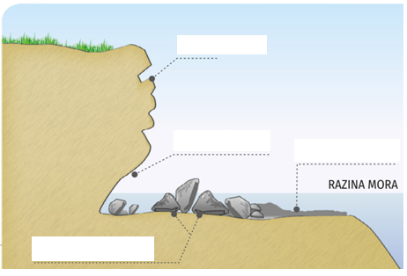

U prazni pravokutnik na prikazu upiši odgovarajući pojam. Zadani pojmovi su klif, abrazijska terasa i valna potkapina. Jedan je pravokutnik višak.

**2. Skiciraj navedene reljefne oblike.**

A. delta

B. estuarij

**3. Objasni svojim riječima.**

A. Kako more fizički, a kako kemijski djeluje na reljef?

____________________________________________________________________________________________________________________________________________________________________

____________________________________________________________________________________________________________________________________________________________________

B. Opiši *dalmatinski tip obale*.

__________________________________________________________________________________

____________________________________________________________________________________________________________________________________________________________________

**5. Odredi koji pojam opisuje definicija.**

A. Slana i plitka jezera odvojena sprudom od mora. ____________________________

B. Zaljev nastao potapanjem riječnog ušća. ____________________________

C. Pješčani ili šljunčani nanosi na obali. ____________________________

D. Pješčani sprud koji povezuje otok s kopnom. ____________________________